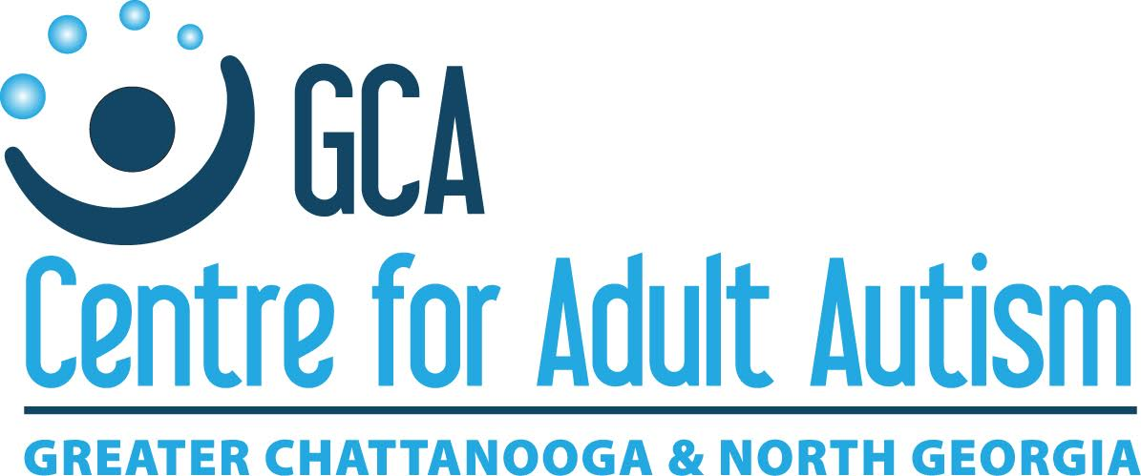

**SPONSORSHIP PACKAGE**

Inaugural Tri State Adult Autism Symposium

Empowering Adults & Young Adults on the Autism Spectrum, Parents & Caregivers, Professionals, Researchers, Family Members, and Others.

**July 22, 2017 ● 8:20 AM to 4:00PM**

**Red Bank Baptist Church ● Chattanooga, TN**

**ABOUT THE SYMPOSIUM**

**MISSION** ▪ Educate adults on the autism spectrum, their parents & caregivers, and

others about Autism Spectrum Disorders regarding adult autism issues.

▪ Present the latest studies and findings and empirically-based strategies and treatments.

▪ Advance the skills of professionals and others who work with the autism community.

▪ Help connect adults with autism, their parents/caregivers, professionals, and others.

▪ Showcase autism-related service providers and help them connect with those seeking

services and also collaborate with other organizations in our community.

**AUDIENCE** This conference is intended for adults on the autism spectrum their parents/caregivers, professionals who work with this population, and other interested individuals to attend the Symposium. This is a first-year, inaugural event, and we expect 135 to 165 people to attend.

**WORKSHOPS** Participants can choose from 11 different sessions (including two sessions of an employment autism symposium). Topics range from employment, independent living, social relationships/skills, health and wellness, autism and society, latest research findings, medical issues, transitions, support systems, preparing for life after school, and much more.

**BENEFITS OF SPONSORSHIP**

* Connect with an audience of adults on the autism spectrum, self-advocates, parents/caregivers,

professionals, researchers, agencies, businesses, government organizations, and other interested

individuals

* Support individuals and families of individuals living with autism to attend and participate in the Inaugural Tri State Adult Autism Symposium Conference
* Associate your organization with the GCA Centre for Adult Autism and Chattanooga Autism Center

**2017 Sponsorship Options**

**Founding Sponsor -** $2,500+

* Introduces keynote speaker (optional)
* Billed as “Key Note Speaker Underwriter”
* Recognition on the Chattanooga Autism Center and GCA Centre for Adult Autism Facebook Groups (over 1700 members)
* Free Premium Exhibitor Space plus free conference registration (2 total)
* Full page ad in Symposium program
* Recognition during workshops
* Largest logo on slideshow in all conference rooms between talks
* Largest logo on website and conference programs
* Your organization’s literature placed at all tables at lunch and at check-in
* Largest logo on signage at conference and at check-in table
* Full 3 x 4 sign recognizing you the leading sponsor
* Recognized as the leading sponsor on all materials and lead underwriter of A/V services in all rooms

**Platinum Sponsor -** $1,200

* Introduces speakers at one or more sessions of a theme (optional)
* Billed as “underwriter” of that theme (sponsor’s choice - Employment, Independent Living, Social Relationships/Skills, Health and Wellness, or Autism and Society)
* Recognition on the Chattanooga Autism Center and GCA Centre for Adult Autism Facebook Groups (over 1700 members)
* Free Premium Exhibitor Space plus free conference registration (2 total)
* ½ page ad in Symposium program
* Large logo on slideshow in all conference rooms between talks
* Large logo on website and conference programs
* Large logo on signage at conference
* Recognition during workshops
* Full 2 x 3 sign recognizing you as a Platinum Sponsor

**Gold Sponsor -** $800

* Recognition on the Chattanooga Autism Center and GCA Centre for Adult Autism Facebook Groups (over 1700 members)
* Free Premium Exhibitor Space plus free conference registration (2 total)
* Large logo on website and conference programs
* Large logo on signage at conference
* ½ page ad in Conference Program
* Recognition during conference
* Large logo on slideshow in all conference rooms between talks
* Full 1 x 2 sign recognizing you as a Gold Sponsor

**Silver Sponsor** - $400

* Recognition on the Chattanooga Autism Center and GCA Centre for Adult Autism Facebook Groups (over 1700 members)
* Free Premium Exhibitor Space plus free conference registration (2 total)
* Logo on website and conference programs
* Logo on signage at conference
* ¼ page ad in Conference Program
* Recognition during conference
* Logo on sponsor slideshow in all conference rooms between talks

**Friends of GCA sponsor** - $125

* Listed on Program and Chattanooga Autism Center/GCA Centre for Adult Autism websites as supporter

**A LA CARTE OPTIONS**

▪ Quarter page ad in Symposium program: $75. ~4.3” wide by 5.5” tall

▪ Half page ad in Symposium program: $200. ~8.5” wide by 5.5” tall

▪ Full page ad in Symposium program: $375. ~8.5” wide by 11” tall

▪ Quarter page ad in Symposium program: $75. ~4.3” wide by 5.5” tall

▪ Business card sized ad in Symposium program: $50. ~3.5” wide by 2” tall

▪ Underwrite Coffee and Refreshments: $500.

▪ Underwrite Audio/Visual for Symposium: $500.

▪ Underwrite lunch for all attendees: $1,500.

▪ Your organization’s brochures to be included

in “goody bags” for attendees $ 50. Brochures must be received by the Chattanooga

Autism Center, no later than 5:00 PM on Friday,

July 14, 2017.

**PREMIUM EXHIBITOR SPACE**

▪ Exhibitor table, linen, and two chairs in exhibitor room

▪ 1st choice of exhibitor spots

▪ Listed on program and Chattanooga Autism Center & GCA Centre for Adult Autism websites as “Friends of GCA” sponsor

▪ Two conference registrations and lunches provided

▪ Option includes for brochures to be included in “goody bags”

|  |  |  |  |  |  |  |  |  |  |
| --- | --- | --- | --- | --- | --- | --- | --- | --- | --- |
|  | **Inaugural Tri State Adult Autism Symposium** | | | | |  | EMPLOYMENT | | |
|  |  |  |  |  |  |  |  |  |  |
|  |  |  |  |  |  |  | INDEPENDENT LIVING | | |
|  |  |  |  |  |  |  |  |  |  |
|  | Saturday, July 22, 2016 | | | **SYMPOSIUM AGENDA** | | | HEALTH AND WELLNESS | | |
|  |  |  |  |  |  |  |  |  |  |
|  | Red Bank Baptist Church | | |  |  |  | SOCIAL RELATIONSHIPS/SKILLS | | |
|  |  |  |  |  |  |  |  |  |  |
|  | 4000 Dayton Pike, Chattanooga, TN 37415 | | | | |  | AUTISM AND SOCIETY | | |
|  |  |  |  |  |  |  |  |  |  |
|  |  |  |  |  |  |  | NETWORKING EVENT | | |
| 7:15 - 8:15am | --Check in at Registration Table to get badges and goody bags-- | | | | | | | | |
|  | Room 1 | | | Room 2 | | | Room 3 | | |
| 8:20-9:20 am | Employment 1: Training for Service Providers | | | Independent Living 1: Conservatorship or Other | | | Health & Wellness 1: Cook Once-Eat All Week or Vanderbilt Trans-Institutional Program | | |
|
|
| 9:20-9:40 am | BREAK | | | | | | | | |
|
| 9:40-10:40 am | Employment 2: Discussion Panel of Parent, Adult, Service Provider | | | Independent Living 2: Other or Conservatorship | | | Social Relationships/Skills 1: Social Skills Development | | |
|
|
| 10:40-11:00 am | BREAK | | | | | | | | |
|
| 11:00-11:50 am | Breakout Sessions (by group): Parents, ASD Adults/Young Adults, Professionals, Other Family Members and Friends | | | | | Breakout Session: Support Group Leaders | | | |
|
|
|
| 12:00 - 1:40 pm | Lunch and keynote speaker - Courtney Bolden, PhD, UCLA Peers Program – visit exhibitors | | | | | | | | |
|
| 1:40-2:40 pm | Employment Symposium: Results from "Impact of Vocational Rehabilitation (VR) Services for Young Adults with ASD" Research Study. Deanna Swain, Virginia Tech | | | Autism and Society: Variety/Talent Show | | | Health and Wellness 2: Cook Vanderbilt Trans-Institutional Program or Cook Once-Eat All Week | | |
|
|
|
|
| 2:40-3:00 pm | BREAK | | | | | | | | |
|
| 3:00-4:00 pm | Employment Symposium: Employment and Adult Autism. Lynnette Henderson, PhD, Vanderbilt | | | Breakout Session: Tri State Adult Autism Coalition | | | Social Relationships/Skills 2: Keeping Friends/Developing Romantic Relationships for ASD Adults | | |
|
|
|

Two Day Symposium Agenda

# Friday, July 21, 2017

|  |  |
| --- | --- |
| 3:00 pm to 5:00 pm  6:00 pm to 10:00 pm | Welcome Reception, First-Centenary United Methodist Church, Chattanooga, TN for adults and young adults on the autism spectrum  Restaurant/Dining Out Event, Chattanooga, TN area for adults and young adults on the autism spectrum (with optional event(s)) |

# Saturday, July 22, 2017

|  |  |
| --- | --- |
| 7:15 am to 8:15 am  8:20 am to 9:20 am  9:20 am to 9:40 am  9:40 am to 10:40 am  10:40 am to 11:00 am  11:00 am to 12:00 pm  12:00 pm to 1:40 pm  1:40 pm to 2:40 pm  2:40 pm to 3:00 pm  3:00 pm to 4:00 pm  6:00 pm to 8:00 pm | Registration and Check-In/Attendees, Speakers, Exhibitors, Volunteers  1st morning session  Break  2nd morning session  Break  Breakout sessions for adults on the autism spectrum, parents/caregivers, professionals, researchers, etc. and breakout session for support group leaders  Lunch, keynote address, awards presentation, prize giveaway, visit exhibitors  1st afternoon session and employment research symposium  Break  2nd afternoon session, employment research symposium, and breakout session for Tri State Autism Consortium  After social event (dinner, etc.) and closing reception for adults and young adults on the autism spectrum |
|  |

SAMPLE TWO DAY SYMPOSIUM AGENDA

**Inaugural Tri State Adult Autism Symposium Sponsor Form**

Please fill out and fax, email, or mail:

scott.kramer@chattanoogaautismcenter.org Fax: 423-521-8094 (email Scott in advance and let him

know you will be faxing your exhibitor form)

Chattanooga Autism Center Phone: 423-531-6961 x4 (Dave Buck, Chattanooga Autism

1400 McCallie Avenue, Suite 100 Center executive director)

Chattanooga TN 37404 423-531-6961 x7 (Scott Kramer)

COMPANY NAME: ___________________________________________________________

CONTACT NAME: ____________________________________________________________

ADDRESS: __________________________________________________________________

EMAIL: ____________________________________________________________________

WEBSITE: __________________________________________________________________

SPONSOR/EXHIBITOR LEVEL ___________________________________________________

I would like to sponsor at the level of (please check one):

____ Founding Sponsor - $2,500 or more

____ Platinum Sponsor - $1,200

____ Gold Sponsor - $800

____ Silver Sponsor - $400

____ Friends of GCA Sponsor - $125

____ Other $ ___________

____ I would like to personalize my sponsorship level, please contact me to discuss the cost

PAYMENT INFORMATION (please check one):

___ Check enclosed

___ Invoice me (can pay in advance or on the day of the Symposium)

___ Charge a credit card (5% processing fee added) Call to process credit card over phone.

Make all checks payable to Chattanooga Autism Center. Chattanooga Autism Center is a nonprofit 501c3 organization: Tax ID# 45-3179418